**IMPAIRMENT MODEL**

**TERM LOAN PD CALCULATION**

**Adjustment to the Advance portfolio file. (Current Year – 2017)**

**1 – Converting LST File to Excel file.**

1. Converting LST (text) file to XLS file.
2. Delete Row numbers 1 to 3 and the last row.
3. Using Text to Column option Separate the each columns based on Symbol (|).
4. After separating the text save it as excel file.

**2-Insert Columns to portfolio file.**

**a.)SLFRS Product Old Code**

1. Add SLFRS product old column after column F

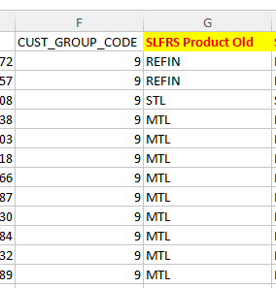

1. Go to SLFRS OLD Product file to obtain this Code.
2. Copy Paste Scheme Code(Column “U”) from Advance portfolio file to SLFRS OLD PRODUCT File
3. Using VLOOKUP map the Fin product as SLFRS OLD PRODUCT Column based on Scheme Code.

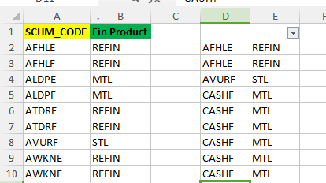

This Will Be the Result after VLOOKUP and Need to Copy it to AP file

+

1. Copy the SLFRS Product code (Column “E” Shown Above) to Portfolio File from the SLFRS OLD PRODUCT.

**b.) Obtaining SLFRS Product Code New**

1. Add SLFRS Product New Column Next to SLFRS OLD Product Column.
2. Go to SLFRS New Product file to obtain this Code.

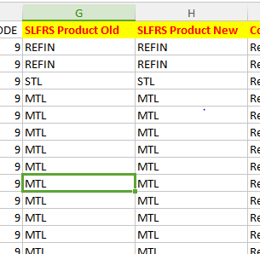

1. Using VLOOKUP map the Fin product as SLFRS New PRODUCT Column based on Scheme Code. (As Above)

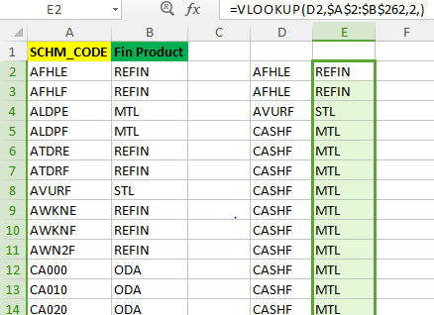

This Will Be the Result after VLOOKUP and Need to Copy it to AP file

+

+

1. Copy SCHM_CODE (column “U”) from the portfolio file to the SLFRS PRODUCT New File. (As Done Previously)-Shown in the Above Illustration.
2. Using VLOOKUP Function Map the SLFRS New Product to the Scheme Code.
3. Copy the SLFRS Product code New (Column “E” Shown in the Above Illustration) to Portfolio File under SLFRS NEW PRODUCT.

**c.) Identifying Corporate/Retail Customers**

1. Identification of Corporate/Retail Customer Column Next to SLFRS new Product Column.

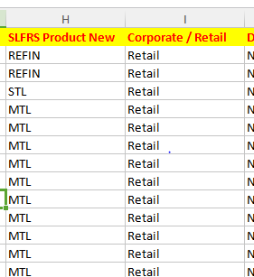

1. Access the Corporate retail File.
2. Do a VLOOKUP on the Corporate ID’s and identify Rest As retail.

Illustration - Corporate File CUST ID Original Sheet

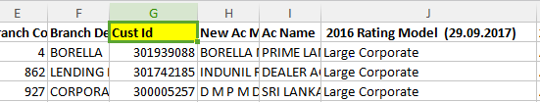

Illustration - Corporate File CUST ID New Sheet.

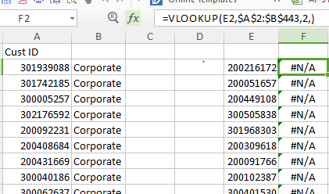

This Will Be the Result after VLOOKUP and Need to Copy it to AP file

+

1. Copy CUST_ID (column “G”) of Corporate File to a new Sheet and Copy Cust ID’s (Column “E”) from Advance portfolio to new Column in that Sheet do the VLOOKUP ALL the results comes as NA are retail Customers.Shown In the Above Illustrations.
2. Copy the result to the Corporate/retail Column.
3. Replace All the NA result with Word “Retail”.

**d.) Identifying Due from Banks**

1. Add New Column Next to Corporate/Retail and named due from Bank.
2. Go to Workbook named Bank
3. Copy the Customer ID to the Bank file from Advance Portfolio file.
4. Do the VLOOKUP and Get the Answer.
5. Copy the Results to the Bank column in the Advance portfolio.

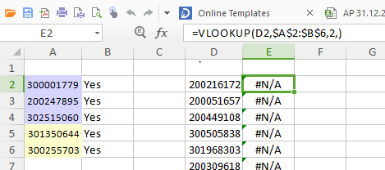

This Will Be the Result after VLOOKUP and Need to Copy it to AP file

+

+

1. Replace the NA as No.

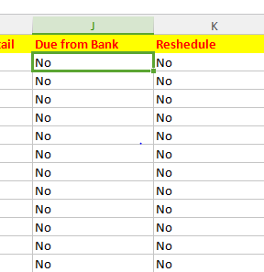

**3–Identifying Rescheduled Customers**

1. Add a Column as Rescheduled Loans next to Due from bank in Advance portfolio File.
2. Create New Excel Sheet and rename it as Rescheduled Loans.
3. Filter the Records in the portfolio file based on the SLFRS Product new to identify the Rescheduled Loans.

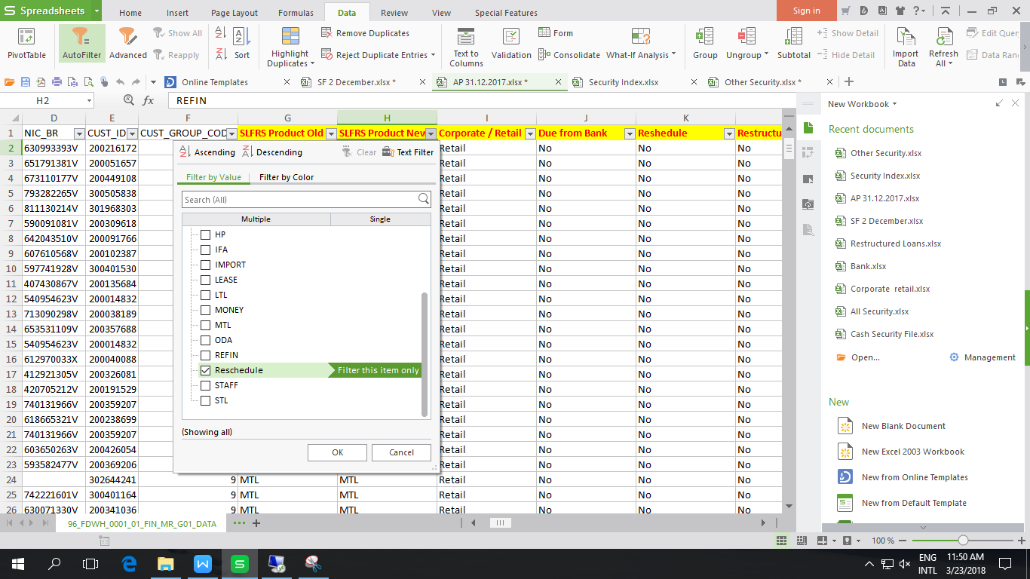

1. Copy Customer ID of Filtered Customers Paste it to new workbook called Rescheduled Loans.
2. Include a column named as status and name All the Account IDs as Rescheduled.

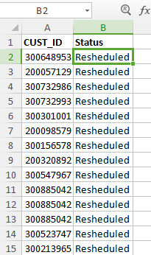

Should Mark Status of ALL CUST ID as Rescheduled for the Purpose of Finding Rescheduled Customers

1. Copy All the Customer IDs from Advance portfolio file and paste to Rescheduled loan Excel sheet

Note – Where One customers loan is rescheduled All Customer Loans Should Classify as Rescheduled.

1. Using VLOOKUP obtained whether the Customer ID is Rescheduled or Not.

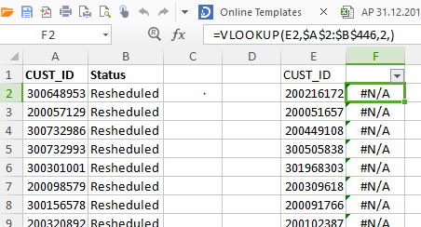

+

1. Copy the results to Rescheduled Column the Portfolio File.
2. Replace NA as NO.

**4 -Identifying Restructured Loans**

1. Add a new Column as Restructured next to Rescheduled in the Advance portfolio file.

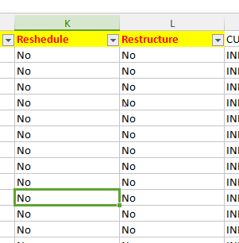

1. Refer Restructured Loans in the Separate excel File and Name it as restructured Loans.(Check whether this is CSV File)
2. Copy the FORACID (account number) to a new Sheet.

+

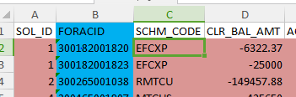

FORACID represent the Account Number. And need to mapped against CUST ID to Find Restructured Customers as Shown Below

1. Copy Account Number field to the Restructured Loan File from Advance portfolio file(Column H ).
2. Copy Customer ID to the Column I in Restructured Loan File from advance portfolio file.

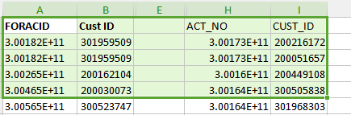

1. Convert FORACID field in to Number format.
2. Using VLOOKUP function get the Customer ID relevant for the particular FORACID code.

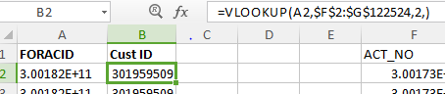

+

1. Copy the Result in to Different Column in the Sheet.
2. Next Column Marks As Status

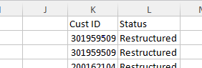

1. Mark the Results As Restructured.
2. Copy the Customer ID again from the Advance Portfolio to New Column.
3. Using VLOOKUP Check the Customer ID whether Restructured or Not.

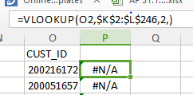

+

1. Paste the Result in the Restructured Column in Advance Portfolio and Paste the NA as NO

**5-Idientifying Arrears Months Bucket**

1. Go to Column Named Arrears_days in the Advance portfolio file.
2. Add a new Column Called Arrears month Bucket next to Arrears_days.
3. By Using IF function get the Arrears Month Bucket.

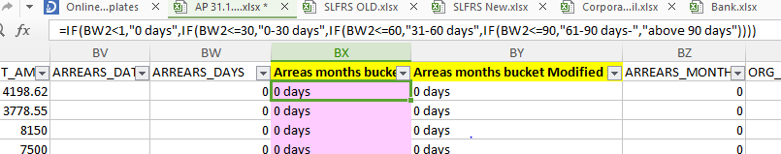

+

+

1. Add Another Column named Arrears month Bucket modified 1 next to Arrears month Bucket.
2. If Sub Classification Equals to 2A 2B 2C and 2D then Classify all as above 90 days Bucket else normal Bucket.

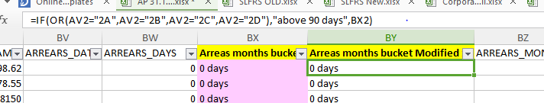

Customers Categorized as 2A, 2B, 2C and 2D should be fall under above 90 Days Arrears Bucket due to High Risk.

+

+

**6 - Finding Amortized Cost**

1. Insert a Column to Covert the LKR_BALANCE to Positive Adding New Column named LKR Positive Balance

+

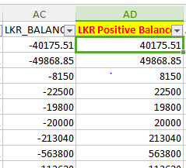

Original Balance Comes As Negative need to convert it to Positive

**a.) Calculating Interest Receivable.**

1. Add Column Called Interest Receivable next to CURRENT_PROVISION Column.

+

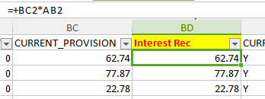

1. Get the Values to the Interest Receivable by Multiplying CURRENT PROVISION By Currency Rate.

**b.) Calculating Shortfall Balance**

1. Add New Column Next to SHORTFALL_BALANCE Column.
2. Get the Converted Values by Multiplying with Exchange Rate to New Column and Name It As SHORTFALL LKR.

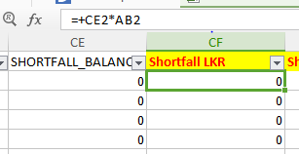

+

**C.) Calculating SF 2 Balance**

1. Add Another Column Called Shortfall 2 Balance Next to Shortfall LKR Column.

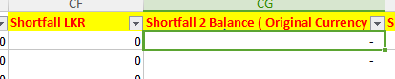

Need to Get from SF2 Report

1. Use Separate File Received from the Data Ware House Called Short Fall 2.
2. Convert the Short fall 2 File to Excel Original File Receiving as LST.
3. Do the Steps as Advance Portfolio File to Get it Convert.
4. OUTSTANDING_AMT is the Short fall 2 balance.
5. Add Column Next to it and Convert it to Positive balance.

Illustration - Original Shortfall 2 File

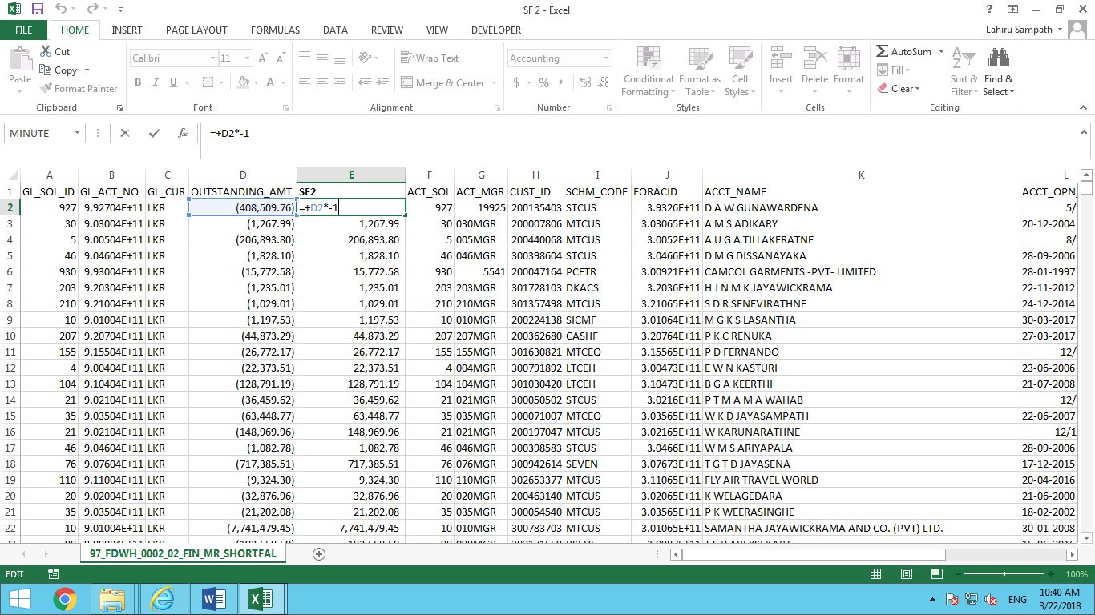

Illustration - Short Fall 2 File After rearranging.

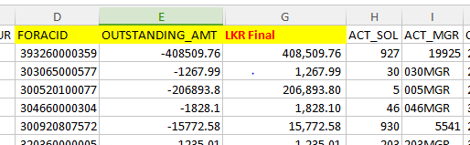

1. Name the column as LKR Final Column Should Be after the FORACID Column.
2. Copy FORACID number and Paste it in Shortfall 2 File before the LKR Final Value As Shown in the Above Illustrations.
3. Copy Column B (ACT_NO) from Advance Portfolio File to the Short Fall 2 File.

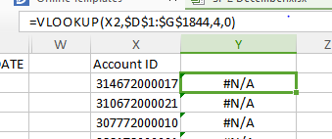

1. Using VLOOKUP function Obtain the SF2 Balance As Shown Above.
2. Copy the results in to the Main portfolio File to a new column(Column “CG”).
3. Replace NA as 0
4. Name the Column As Short fall 2 Balance Original Currency
5. Add New Column Next to it name it as Short Fall 2 Balance LKR

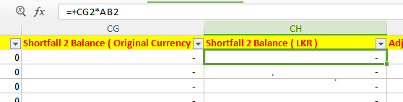

+

1. Convert it to Currency rate(Original Curr *Currency rate)

**d.) Calculating Adjusted Shortfall Balance**

1. Add New Column Called Adjusted Short Fall.
2. Get the Values By Short Fall LKR 1 - Short Fall LKR 2

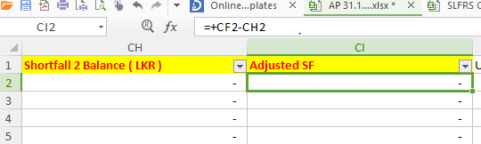

+

1. Add New Column Called Adjusted Short Fall/Interest Receivable
2. By Using IF Function get the Values as if Sub Classification equals 1A get Interest Receivable otherwise Adjusted Shortfall.

+

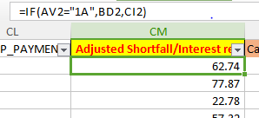

**e.) Amortized Cost Calculation**

1. Add a New Column Called Amortized Cost.
2. Get the Amortized Cost Based on the Below Formula.

=AD2+CM2-AdjustedShortfall/Interest Rec.

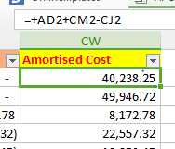

+

**7 - Extracting Security Details**

**a.) Extracting Non Cash Security Details.**

1. There are two security files

1. Cash Securities and

2. Non Cash

1. If Files Received as LST need to convert to Excel.
2. Open the Non Cash File.
3. Processed Lien Amount is the Security Amount
4. Sec_Riz_Index - this field gives the Security Classification.
5. Facility Account is Account ID
6. Add two New Column next to Process Lien Amt called Rate and Security 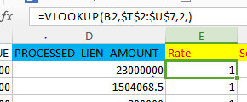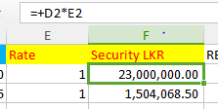

+

1. By Using VLOOKUP function Find the Currency rate in to Rate Column(Processed Lien amt*Rate)
2. Get the Converted Values to Security LKR column.
3. Copy Sec_Riz_Index in to a New Column and Insert New Column named Security Type.
4. There is Another File Called Security Index Get the table from that and past it in a new sheet in other security file.

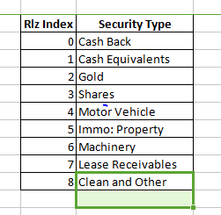

1. Get the Security Type by referring to that table based on the Security Riz Index Code.

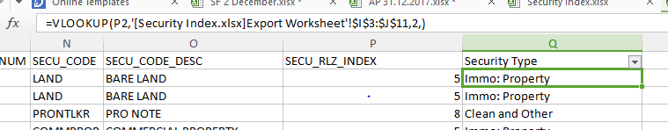

**b.) Extracting Cash Security Details.**

1. Open the Cash Security File
2. Add two New Column next to Process Lien Amt called Rate and Security LKR
3. Obtain the Rates from the Advance portfolio file as done in the Above File and Convert it to LKR

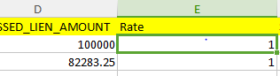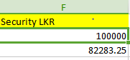

**C.) Creating All Security File.**

1. Create a New Excel File Called ALL Securities
2. Open Other Security File.
3. Copy Facility Acc from the Other Security file to All Security File.
4. Then security LKR Value
5. And Security type

Illustration - All Security File

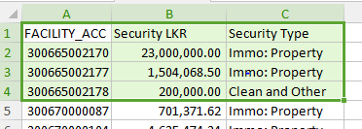

1. Close the Other sec file and Open Cash Sec file.
2. Get the facility Acc number and Paste it Below the Earlier pasted one in the All Sec file.
3. Copy The Sec value and paste it also
4. Named the Security Type as Cash Equivalent for All the Cash Securities.

Illustration - All Security file pasting Cash Security Data

Cash Security Details Should Paste Under the Non-Cash Items As per Heading in Above.

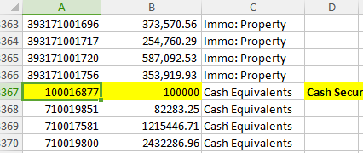

1. Create a Pivot Table

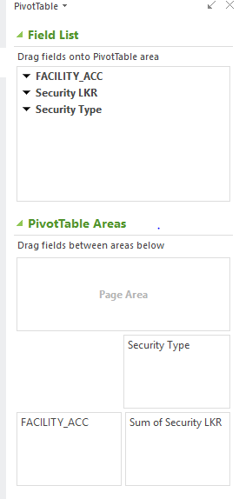

1. Copy the Pivot Table to a New Sheet.
2. Add 8 Columns Before Amortized Cost



1. Include the security names to those Column As Above.(Security Types we have Obtained from Security Index File)
2. By Using IFERROR and VLOOUP Update the Security value in the All Security file Mapping should be done to Facility Number by Referring to copy pasted Pivot Data in the Step 106.

Illustration 1- Formula Used to obtain the Value

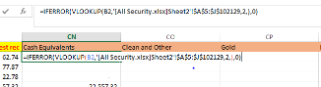

Illustration 2-Values after using the formula 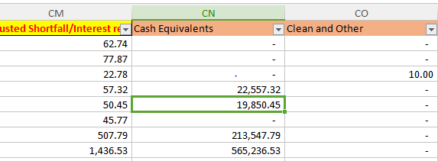

+

**d.) Checking Security Values**

1. Get the Sum of Security Cost and Check whether it is tallied to Amortized cost By Getting Difference between Amortize Cost and Sum of Securities.

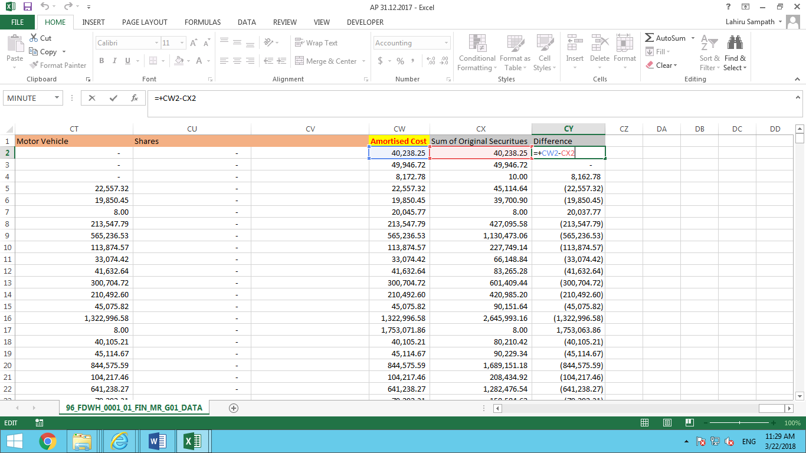

1. Name two Columns as SUM of Securities and Difference (Last two columns).
2. Insert a New column before the amortized cost column called Clean Security and Paste the Difference to that Column.
3. Update Formula for Sum of ALL Securities by Including the Clean Securities.

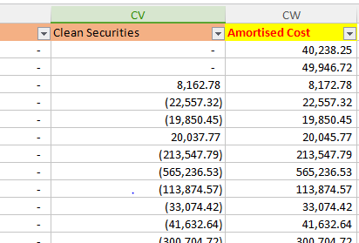

+

1. Check Whether the Difference is 0
2. Delete the Last Two Columns After that (Sum of Sec And Difference).

**e.) Breaking up Security as Above below**

129. Inserting New Column Next to the Sanction Limit Called Limit LKR

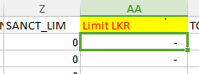

130. Convert Sanction Limit to LKR (Column Z) By Multiply it by Currency Rate and get the results for Limit LKR Column.

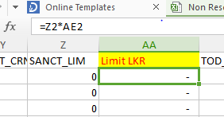

131. Add two new Columns Next to Imm. Property (Column CW & CV)

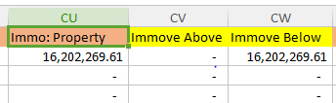

132. Name Two as Immove Above and Immove Below.

133. If Limit LKR >= 5mn take the Immov Property as Above or 0

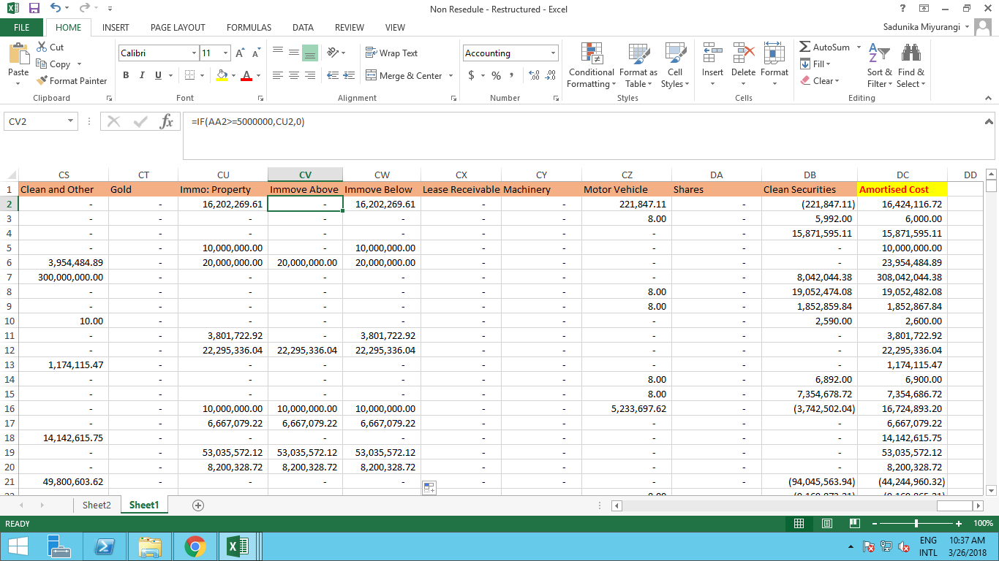

134. If Limit LKR < 5mn take the Immov Property as Below or 0

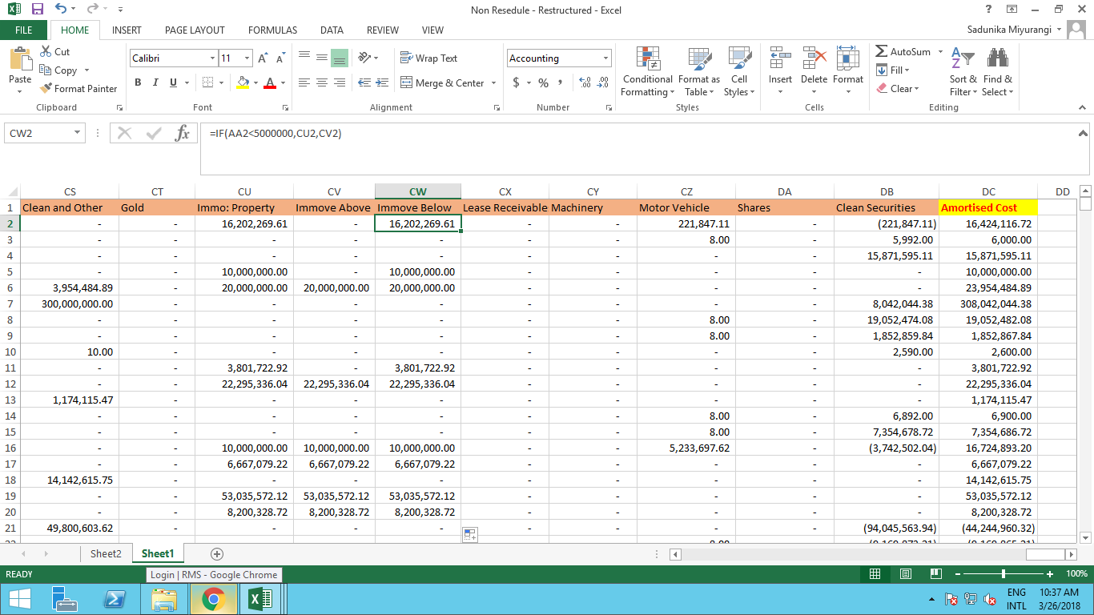

135. Paste Special both Columns Below And Above.

**8 - Identifying Industry**

116. Insert New Column Named Industry After the Sec Description (Column “AJ”).

Illustration - Non Rescheduled and Non Restructured Loan File

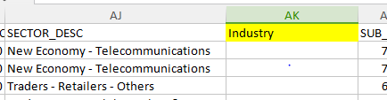

117. Open the File Named Industry Mapping

118. Using VLOOKUP Get the Industry by mapping it to Sec Description

Illustration - Industry Mapping File table with Sec Description Mapped to Industry

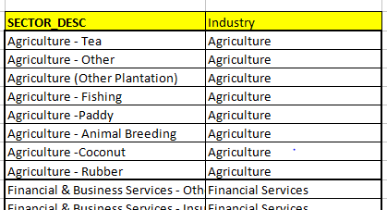

Illustration - Non Rescheduled and Non Restructured Loan File After doing VLOOKUP

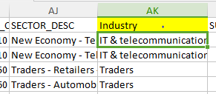

119. Copy and paste the results as Values obtained from VLOOKUP.

120. If the Sec description is #NA Update the Sec Description As “Others”.

**9 - Calculating Remaining Maturity (YTM)**

When Converting Advance Portfolio File Column Q & R & AV (Expiry Date and ACCT_OPN and AS_ON_DATE) Should Be Converted As Dates Using Text to Column

121. Inset New Column for YTM Next to EXPIRY DATE (Column “S”)

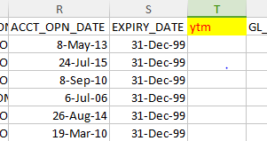

122. Get the Value for YTM By Deducting EXPIRY DATE minus AS_ON_DATE Divided By 365

Using Below Excel Function (Screen Shot 2)

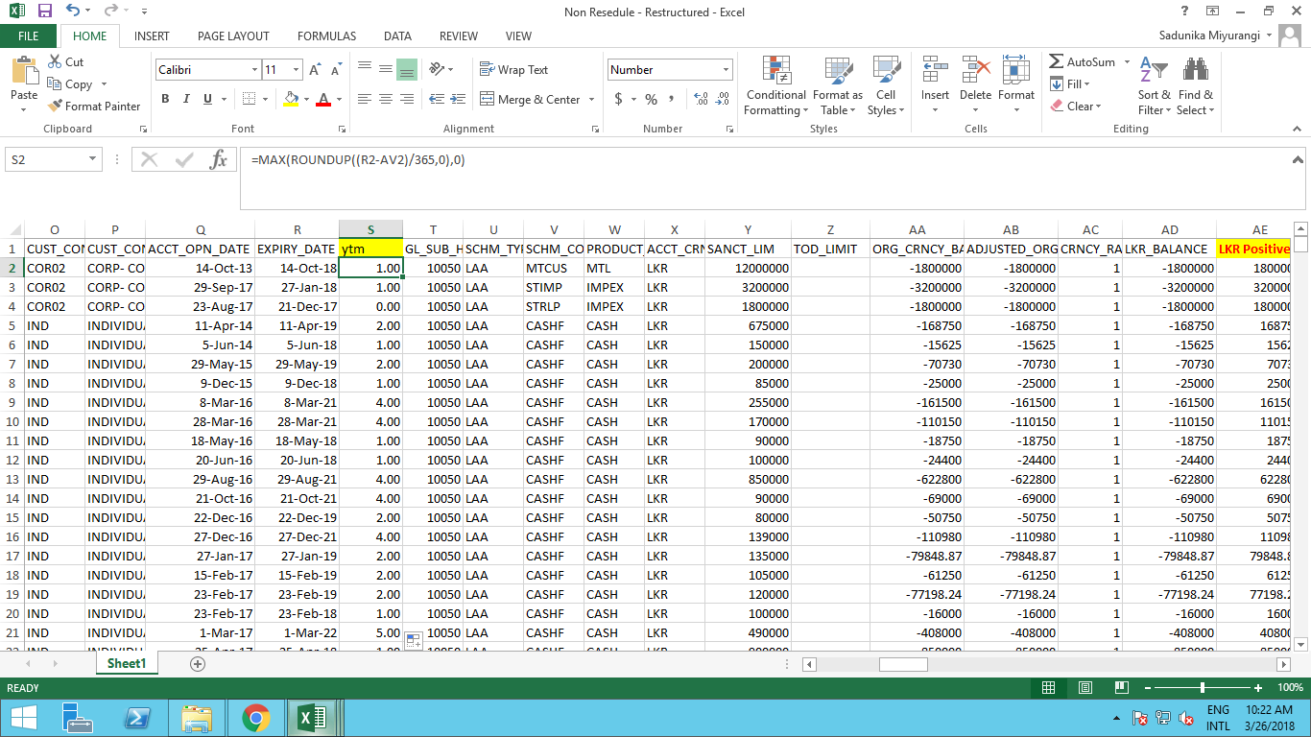

123. Do the paste Special for YTM Value.

**10 - Inserting Individual Impairment for Advance Portfolio**

124. Insert a New Column Next to Restructured Column Named ISL

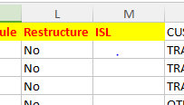

125. Open the Individual Accounts File.

126. Do A VLOOKUP to Get Result in the Column D from Individual Account File based on Account Number.

Illustration - Individual Impairment File (Column D text need to be obtained by VLOOKUP)

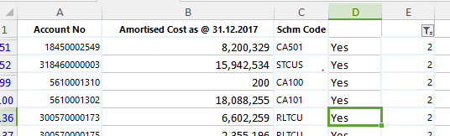

127. Copy paste it As Values.

128. Replace the #NA as “No” and keep All Other As “Yes”

**11 - Splitting the Portfolio in to 3 Categories.**

136. Filter the Rescheduled Column the Advance Portfolio file and Copy All Records New Excel Workbook.

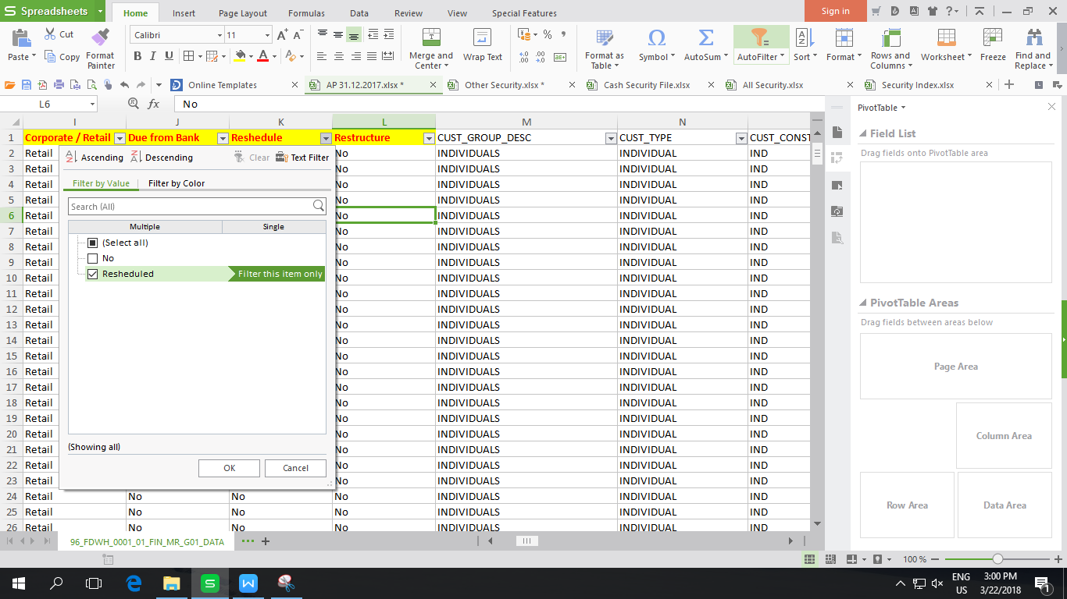

+

137. Filter the Non Rescheduled Loans By Filtering Reschedule by “NO” and Yes In Restructured

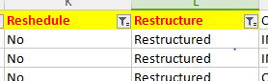

+

138. Copy Those Records to a New Excel named As Restructured Loans.

139. Filter the Rescheduled as “NO” and Restructured as “NO”

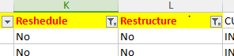

+

140. Copy the Record to a new Workbook.

141. Save it as No Rescheduled and Non Restructured.